The SEND Local Offer Website – Annual Report
April 2022
Welcome to the 2021-2022 annual report for Birmingham’s Special Educational Needs and Disability (SEND) Local Offer website

Introduction
Birmingham’s SEND Local Offer website provides information, support and services for children and young people from 0-25 years, all in one place.
It has sections on: Education, Early Years and Childcare; Social Care, Health and Wellness, Travel and Transport, Information and Support, Advice and Resources, Money Matters, Places to go, Things to do, Preparing for Adulthood, Policy and Forms Library, and more.
Parents, children, young people and practitioners can search by age, district or type of service, such as commissioned, voluntary or private.
The SEND Local Offer website for Birmingham was relaunched on 1st April 2021 with a new image, website layout and fully compliant with the SEND Code of Practice.
Whilst progress has been made there is still more to do and we are working hard to continuously improve the content and the style and structure of the Local Offer website pages.

What the law says
All local authorities must publish a SEND Local Offer, setting out in one place information about services and support available for children and young people in their area who have special educational needs and/or disabilities.
Local authorities and their partner bodies and agencies must co-operate with each other in its development and review.
The Local Offer has two key purposes:
- To provide clear, comprehensive, accessible and up-to-date information about the available provision and how to access it, and
- To make provision more responsive to local needs and aspirations by directly involving children, young people, parents, carers and service providers in its development and review.

Governance

SEND Local Offer Focus Group
There is an SEND Local Offer Website focus group that has oversight of the SEND Local Offer and reports to an overarching SEND Management Group. The group has responsibilities to ensure that the SEND Local Offer website meets the statutory obligation laid out in the SEND Code of Practice 2015. The group meets monthly with representation from parents/carers and professionals from education, health and social care.

Specific Areas for the SEND Local Offer Focus group
- To ensure the SEND Local Offer meets its statutory responsibilities as outlined in the Children and Families Act 2014 and SEND Code of Practice 2015.
- To involve children and young people and parents and carers in the development and review of the SEND Local Offer.
- To ensure the site is accessible.
- To promote the site and ensure all stakeholders are aware of their role and duties.
- To keep the content under review, ensuring that the SEND Local Offer is:
  - developed and continuously improved
  - reflects services in the local area
  - accurate and up to date
  - easy to understand
  - easy to use
  - meets the requirements of children and young people and parents and carers.
Website analytics

How many have people have visited the SEND Local Offer website?
- 1 April 2021 - 31 March 2022 the SEND Local Offer had 296,296 page views (222,577 unique page views).
- 1 April 2021 - 31 March 2022 the SEND Local Offer had 69,777 users.
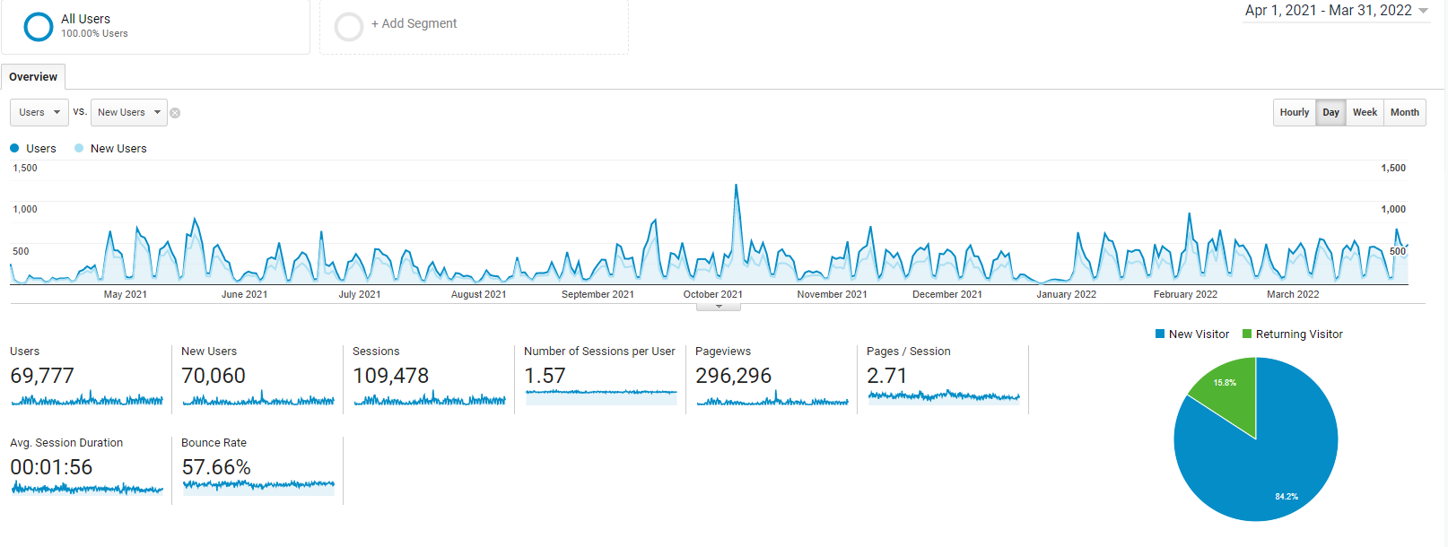
A user is a visitor who has initiated at least one session during the date range.

What did they look at?

Top 5 most popular information pages, (after the home page) for 2021/22 were:
    - Professionals and education settings
    - Professionals and educations settings/education health and care plan
    - Parents, carers and young people
    - Checkout
    - Events for parents
This reflects the popularity of webinars for parents, and that more professionals are using the site than families.
How did they access it?
Device used 2021/22:
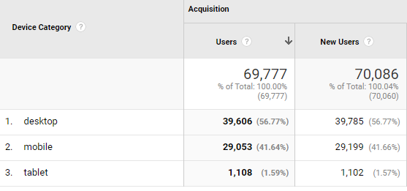
Again, this reflects the number of professionals using the site – there is a very high proportion of users using desktops. Typically, mobile is 55% and desktop 42% in the UK https://www.smartinsights.com/search-engine-marketing/search-engine-statistics/

Impact from information provided by website analytics:
- There is still work to do on promoting the SEND Local Offer website to families as the analytics indicate that professionals are the majority of visitors.
- Parents and carers value and use the events page and webinars are very popular
- There is a steady overall rise in viewing figures month by month, but more needs to be done to driver visitor numbers up:
Month | Visitors
September 21 | 31,430
October 21 | 37,991
December 21 | 16,164
January 22 | 29,403
February 22 | 24,321
March 22 | 27,434

Achievements during the past 12 months

Establishing the SEND Local Offer Focus Group

We have set up a group formed of parents, carers, SENCOs, SEND staff (including those working with CYP) from the City Council, Birmingham Children’s Trust and the NHS in order to develop, progress and monitor the site.

Accessibility - In response to feedback from parents, children and young people, the website now features a new accessibility tool which enlarges text and provides text in various contrasting colours to assist partially sighted or dyslexic readers.
Translation - The site now includes a translation tool which can translate text into over 40 of the area’s most commonly used languages.
Search Tool - The search tool has been updated and improved following feedback from families who are now saying that it is far more effective.

You Said, We Did and Feedback Icons - The You Said, We Did and Feedback icons have been moved higher up the Home Page in order that visitors can more quickly find these areas of the website in order to contribute feedback and see progress against suggestions.

Parent and Carer Feedback Events - We have run over 10 engagement events in order to find out what visitors think of the SEND Local Offer website. Feedback from these events and a partnership wide staff survey have informed improvements to the site.

Website name change - Following feedback from parents and carers we have renamed the site the SEND Local Offer website pointing more directly to who the website is for.

6 monthly audit – all areas of the site were audited and revised by head of service, or subject leads in each area of the website.

SEND Local Offer Content

Latest News - A latest news page has been added to the site where parents and carers can easily access current news and the latest newsletters.

Home to School Transport - The Home to School transport area of the website has been overhauled with documents, policies and forms now in one place. A news area has also been added to the HTS area.

Health and Wellbeing - The Health and Wellbeing area has also been overhauled and reorganised to make it easier to navigate.

Preparation for Adulthood - This area has been overhauled and now includes links to colleges and Post 18 options

Covid-19 Information - During the past year, families and practitioners have had to respond to many challenges during the Coronavirus pandemic. We have developed new sections on the SEND Local Offer to share resources, updates and materials that support children and young people’s emotional wellbeing.

Events for parents – this area has been updated and includes more regular information
Directory – work has begun on an expanded directory which will continue to expand and eventually move to a separate area of the site.

Birmingham Children’s Partnership – the work and resources of the Birmingham Children’s Partnership has been uploaded to the site and an Early Help Handbook created for professionals.

Promotion

We continue to promote the SEND Local Offer to parents and carers through schools, using social media, adding an image promoting the website to email signatures, at parent and carer engagement events and in parent webinars. We have encouraged staff to get to know the site and pass the link on to parents. The site is also promoted through newsletters and updates.
Work on a promotional video to introduce the SEND Local Offer has concluded and the video can be seen here https://youtu.be/yamV3F1dez8

Service feedback – You Said We Did

We are always pleased to receive feedback from parents, carers, children and young people. The feedback received and the action we have taken is published on our You said, we did page. Some examples include:
A lot of people don’t know about the SEND Local Offer website is hard to use | We are working hard to make sure that every SEND parent knows about the SEND Local Offer website, via schools, newsletters and social media. We have changed the name to the SEND Local Offer website and have improved the search tool on the website.
There is no signposting to help and support | We are recruiting co-production champions to help you find what you need in SEND support
We are not listening to children and young people | A working group has been set up to capture champion the views of children and young people. We are working with the RISE and Wellbeing Youth Forums, as well as young people from the SENDIASS service. Children and young people are now part of our co-production research and framework.

Mapping the Customer Journey

We are currently recruiting parents and carers to help us to understand and improve the customer journey.

How will mapping the customer journey help?
- look at the Local Offer with a fresh pair of eyes.
- provide insight into keyword searches that may be used by others.
- Test the accessibility of the website.
- Make us aware of any information that is hard to understand or difficult to find
- Tell us if you feel there is anything missing.
- Share what you like about the website so we keep doing it.
- Test on a range of devices.
Feedback from the exercise will:
- Be used to develop the SEND Local Offer website and continue to improve accessibility.
- Look at any information gaps.
Actions are published on our “You said, we did” page on the SEND Local Offer

Partnership Working

We attend a regional SEND Local Offer Group which includes SEND Local Offer representatives from areas across the West Midlands region. The group enables all local authorities within the region to share best practice, experiences, and explore joint working.

Impact of the SEND Local Offer

Parents and Carers
- 'Search is working better'
- 'Didn’t know it was there – would have been ideal if I’d known about it'
Young People
- 'The change of name is good'
- 'It would be good if there was a Young Person zone'
Staff
- 'It is far easier to navigate than it was previously'
- 'It needs more pictures and videos, to make it more user friendly for families'

Next steps

- We are looking at an overhaul of the look of the SEND Local Offer website in order to improve navigation of the site
- We are looking at rebranding the site so that it is more dyslexic friendly
- We are investing in more resources so that the site is constantly updated, refreshed, is promoted and works as well as possible for its visitors
- We are continuing to upload video in order to make the site more dynamic
- We are continuing to engage with CYP to improve their experience of the site
- We are continuing to engage with Parents and Carers in order to improve navigation and user experience.

Give us your feedback on the Home Page - https://www.localofferbirmingham.co.uk/
Email - SENDImpComm@birmingham.gov.uk
Look out for parent/carer events where we invite you to feedback in person https://www.localofferbirmingham.co.uk/events-for-parents/
Contact the RISE Youth Forum – youthforum@birmingham.gov.uk

