Birmingham SEND Parent Carer Survey
May 2022

Final Report

Rowan Griffin

28/06/2022

CONTENTS

- Introduction and Purpose 3
- Method 3
- Responses and Key Findings 4
- Section 1: Services and Support 5
- Section 2: Communication and Engagement 11
- How we will use this report and Next Steps 13
- Appendix 1: Survey Screenshots 14
- Appendix 2: Parent Carer Have your Say Report 18

- Introduction and Purpose
Between May 9 and May 27, 2022, an online survey was undertaken of parent carers of children and young people accessing Special Educational Needs and Disability (SEND) services in Birmingham.

The purpose of the survey was to:
- Ask parents and carers about their experiences with Special Educational Needs and Disabilities (SEND) service for their child or children in 2022.
- Gather a broad understanding of their current views on SEND services provided by Birmingham City Council (Education), Birmingham Children's Trust (Social Care) and Health (NHS) in Birmingham.
- Understand parent carer usage and perspectives on the SEND Local Offer Website (www.localofferbirmingham.co.uk).
- Understand the extent to which parent carers feel they are updated and informed, able to give feedback and influence change in SEND in Birmingham.
- Provide a baseline on the above measures which can be measured again through future surveys. Given the need for urgent improvements to SEND services in Birmingham. We want parent carers to tell us if they feel SEND services and engagement are improving over time.

- Method
An online survey was designed on Microsoft Forms, which was available for filling in on PCs, laptops and mobile phones.

Various accessibility functions (such as text-to-speech and other translation functions) were built in via Microsoft forms and accessible colours chosen for the design and text.

The survey opened Friday 6 May AM (Midnight) until Friday 27 May PM (Midnight).

The survey and its questions were co-designed with the involvement of Parent Carer Forum representatives, alongside Officers representing Birmingham City Council Education and Skills Directorate, Birmingham City Council and Birmingham CCG. In total, around 50 individuals were involved in the design of the survey during April 2022.

This survey design focused on a whole system approach across Health, Social Care and Education to try and understand the wide perspectives and experiences of all parent carers of children and young people with SEND. The rationale behind this was to develop a baseline of parent-carer views and that the experience of services is a multi-agency one involving schools, the NHS and Council services.

Screenshots of the Survey and Questions can be found in Appendix 1. The online link to the form has now been switched off.

A disclaimer on methodological limitations.
- The respondents were self-selected and may or may not be representative of all parent carers of children with SEND.
- The responses represent a snapshot in time (May 2022).
- The survey design did not examine individual services in any detail and therefore service comments are based upon self-identification by the parent carer only.
- All survey responses were in English, although translation and additional support services were offered in emails and advertising materials. There is a possible risk that some communities in Birmingham where English is not the first language may be under-represented and more proactive promotion of translation functions is recommended when the survey is repeated next time.,
- To keep the survey short and focused on general baselining of parent carer satisfaction overall, parent carers were not asked questions of location of residence or ethnic background. Further in-depth research in this area could be useful in due course to ensure no key areas or issues were not missed.
- Support was also offered to anyone who requested it and this was promoted in introductory emails and at the beginning of the survey, although no requests were received. Learning from this, for future surveys we will advertise and promote

- Responses and Key Findings
788 responses were received, after filtering out 3 test responses. This was significantly higher than previous surveys (378 in December 2019 and 226 in November 2018), although these had very different questions and focused on assessment and review. The parents and carers had children and young people in their families from a wide spectrum of ages-bands. The majority (76%) had children aged 5 to 16.

Below is a summary of positive responses to key survey questions. These will form a baseline by which to measure improvements over time – we hope through our work the percentages below will increase.

Measure | May 2022
Number of Parent Carers responding to surveys | 788
Overall Parent Carer SEND Satisfaction is “Good” or “Very Good” (all) | 32%
% Parent Carers sayings SEND Services have improved in the last year (all) | 27%
% Parent Carers who have accessed the SEND Local Offer Website | 28%
% Parent Carers who have accessed the SEND Local Offer Website who think it is OK, Good, Or Very Good | 72%
% Parent Carers who feel updated and informed about SEND services in Birmingham | 42%
% Parent Carers who feel they have had an opportunity to give feedback about SEND services in Birmingham | 26%
% Parent Carers who feel they have had an opportunity to influence changes in the SEND Services available in the city | 16%

Section 1 - Services and Support

Overall findings (all responses)

The following % of responses providing an active response (excluding 129 don’t know/have not accessed, 659/788) responses:
- 40% Felt SEND Services were “Very Poor” or “Poor”.
- 32% “Good” or “Very Good”
- 28% “OK”

Overall Parent Carer Satisfaction with SEND
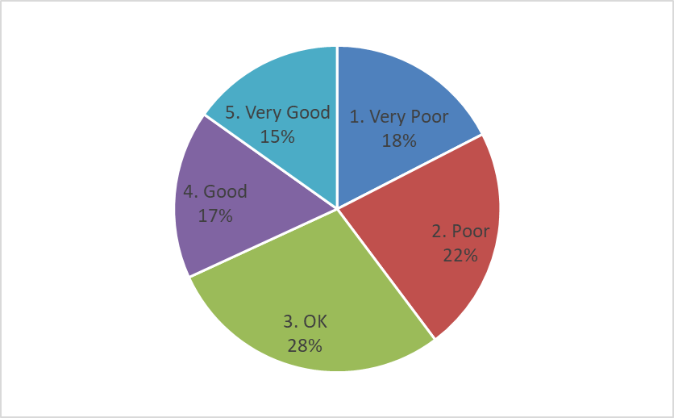

However, where respondents confirmed they had received multiple SEND services in 2022 (205/788) of whom 57% felt SEND Services were “Very Poor” or “Poor”, 25% “OK” and 17% “Good” or “Very Good”. These respondents generally noticed a more positive experience of “Education Setting and School” than other services such as “Other Education”, “Social Care” and Health”.

Comments on overall satisfaction where positive

What does the experience of high parent carer satisfaction look like in Birmingham? Top themes raised when citing a good or very good experience where:

- Often praise for school or SENCO and the quality of support is given. For example,
“I’ve received so much help for my two children with the school senco, one is moving to secondary school and the help I’ve revived has been great.”

“They are so compassionate and take you seriously”

- Where required services have been obtained and now everything is running smoothly.
“I could not wish for a more supportive school for my son - they are amazing”

- Where there had been support for the family and professionals have listened.
“I have met good people, they explain to me properly about my child assessment, because my English is poor , they find out a way to explain me to understand.”

- Some isolated comments on a high quality EHCP process where waiting times have been short – a small number of positive references to the online Healios assessment are noted:
“Healios has been amazing!”
“EHCP process and dealing has been good. No long wait times due to a healios assessment being arranged”

To offer a broader example:
“Ever since SEND became involved in my child’s development, I've never really known when they come to see my son and what the outcome was but this year, I was fully involved in my son's support plan and what will be done to further help with his development. This gave me a sense of relief and peace of mind cause I knew what to expect and how person-centred his support plan was.”

Comments on overall satisfaction where “poor” or “very poor”

There are many reasons cited, but the most common are the following.

1. Health

- Poor Communication/Listening/Compassion is often cited, often resulting in cancellations, delays and a lack of access to services.
“Physio - constant cancellation, Referral to OT - not existent as no one wants to make it, SENAR - Refusal to issue plan when no statutory advice received from setting, so it is penalising the child and family rather than getting statutory information from school! No help securing a place for NEET daughter who has EHCP just left to it. FTB no help as advise to go to the unsupportive school for a referral to STICK which again doesn't happen”.

“Poor response, lack of communication staff attitude is poor”.

- Waiting Lists (in particular for Health services) are another concern alongside the quality of assessment and communication.
“GP referred my daughter for ASD assessment over 18 months ago when we got the appointment it was for ADHD. We still attended the assessment appointment and I explained that GP had referred for ASD the professional explained that it had been a mistake, I3 months later I am still waiting for the ASD assessment. In the meantime, my daughter had a time when she was unable to access education and is now seeing a Councillor.”

“Waiting 2 years for MRI, my child does not have regular check-ups and his practitioners are difficult to contact”

3. Some parent carers are concerned with a lack of face-to-face visits following Covid. These comments often apply to all services, but often come up when referencing health services.

“All services should book offer a face-to-face appointment directly when it is key to further planning, not wasting time with a virtual appointment first. Do something about the waiting lists.”

“We need doctors to meet patients, frequent, regular and pre-empted face-to-face appointments with specialists, physios, SALT, OT to enable families to know what is possible, what choices are available. Time is precious and children are not being seen at the optimum time in their lives resulting in extra delay and possible long-term damage. Covid should now not be an excuse for this”.

“My son's school had to make a special request for the CAT/ASD team to have a quick chat with my son as he is still waiting for his ASD diagnosis despite being referred early 2020 and scoring as significantly autistic in diagnosis questionnaires.”

2. Education

Here the most common concerns are around Communication and the quality of the EHCP Process and the SENAR service. The comments often seek more staff, more staff training, better communication skills and more consistent procedures.

Some comments note a need to increase staff capacity and improve / “overhaul” systems. Waiting times are often an area of concern alongside the quality of EHCP.

“SENAR are shocking. No support or no communication. Waiting for a change of placement for the last 18 months and still no communication. Have never had an up-to-date Copy of EHCP. No communication going forward with college transition either.”

“More people employed by SENAR and the health services.”

“Complete things in a timely manner, respond to emails. “

“Need to be able to communicate with Senar more easily. Time taken to complete EHCP updates has improved slightly but process needs to improve….”

The need for more services and specialist placements is regularly raised in comments:
“ Desperately need more settings for more able children with Autism who find it difficult to access mainstream school.”

“Lack of support, feel like we’ve been forgotten about especially when he’s been in and out of learning at different places due to not being able to find a Sen school and one close enough too”

Staff training is often raised:
“Messed around with my child's ECHP and both SENDIASS and SENAR have a lot to be desired. Inexperienced staff doesn't help, or stating conditions your child hasn't got….”

The need for better information and advice is also mentioned often.
“My sons placement was due to end this year. I received no advice, guidance , or preference request from Senar as to what would happen when his placement ended. It was only because I sent numerous emails, made telephone calls etc that Senar finally responded.”

On the other hand, another respondent noted a
“Lack of communication, don’t deal with and signpost rather than support,”

- Social Care / Birmingham Children’s Trust
Where services have been obtained, parent carers are understandably more positive:
“Good managed to get some respite care”.

Where this is not the case, they are more critical:
“Extremely let down and disappointed by the lack of support by social services specifically when we requested urgent respite care and support dependant on our needs and we have been completely ignored and have been denied the help and support that we so desperately need”

“He is getting on much better at school but has been waiting 2 years for an Education Psychology Assessment. Children's trust have failed my son a number of times.”

“Social services will not step up and support a highly vulnerable disabled child after many concerning reports….”
.
“Social care cannot help families in need of house alterations for disabilities as it’s all done through contacts and one box has to be ticked before the next can be looked at.”

“Social care are the main service that needs improvement by carrying out the things they say they are going to do, not just blame lack of workers as reason to fail children and families”.

Overall improvement in the last year

When asked had services improved in the last year (628/788) parent cares gave the following response:
- 45% “The same”
- 28% “Had got worse”
- 19% “Improved”
- 8% “Improved significantly”

Compared to a year ago (May 2021), to what extent have your family's experience of services to support your Child(ren)'s SEND needs improved?
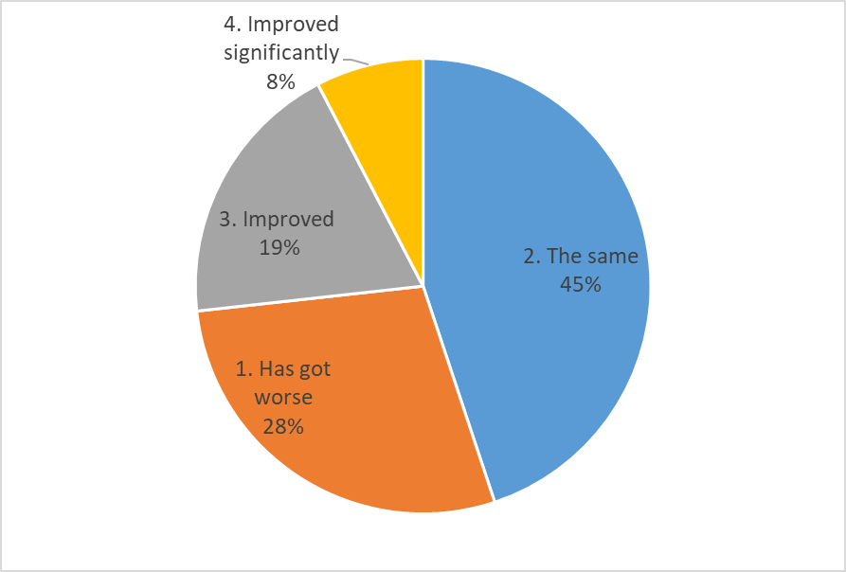

However, overall satisfaction was significantly lower when the respondents confirmed they had received multiple SEND services in 2022.
- 41% “Had got worse” (higher)
- 44% “The same” (similar)
- 11% “Improved” (lower)
- 4% “Improved significantly” (lower)
Respondents were more likely to say that “Education Setting / School” services had “improved or improved significantly” compared to other services (e.g. Health, Social Care and other Education Services).

Reasons for the perception of improvement were often linked to improvements to the school and where services have been provided smoothly with good communication.

Many reasons were also given as to why services have not improved, which are often the same or similar to the reason a service is considered “poor” or “very poor”. Over 1000 separate free text comments are noted in reply to the improvement suggestions question. For brevity and confidentiality, these will not be published in full but have been analysed carefully over a number of days to understand the main points being made.

The following areas are the most commonly cited: better communication, listening and compassion, followed by a need to improve staff numbers and training, whilst also increasing the scale of services and support available and ensuring joined-up services and support.

Simple word cloud of most common single-word responses

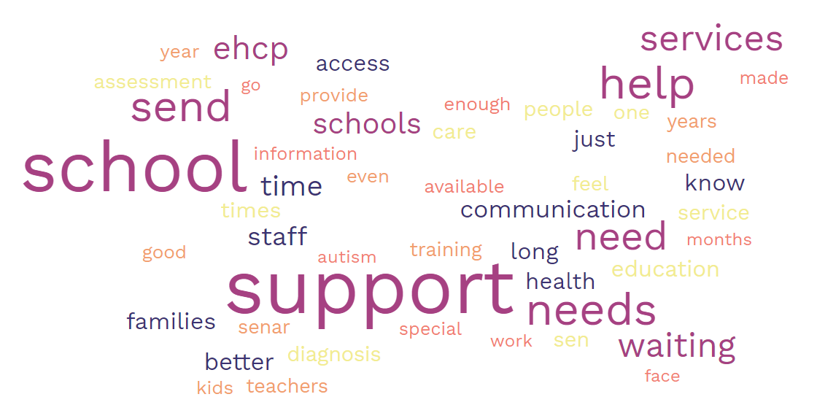

Technical note: The word cloud only captures individual common words so does not fully capture the complexity of more complex messages and sentences in the response, which have also been analysed, grouped and thematised separately.

Section 2 – Communication and Engagement

Use of Local Offer Website and Satisfaction

The majority of respondents had not used the refreshed Local Offer website, with usage proportions in line with the previous 2019 survey.

Have you used the Birmingham SEND Local Offer Website in 2022? https://www.localofferbirmingham.co.uk/

However, of those accessing the website, 37% thought it was useful or very useful, 35% OK and 28% not useful. In 2019, before improvements to the site had been made, the question was worded differently but response proportions were similar to 2022.

On a scale of 1. not useful to 4. very useful, how useful has the Local Offer website been to you in 2022?

Questions were also asked about the extent to which parents and carers felt updated and informed, able to feedback and get involved in SEND service improvements.

Excluding ‘don’t know’ responses, 42% felt they had been kept updated and informed about SEND Services in Birmingham in 2022.

However, proportions are lower for the % who feel they have had an opportunity to give feedback about SEND services in Birmingham. Excluding don’t know responses, 26% replied “Yes a little” or “Yes a lot”.

Proportions are further lower for the % who feel they have had an opportunity to influence changes in the SEND Services available in the city. Excluding don’t know responses, 16% replied “Yes a little” or “Yes a lot”.

In 2022, to what extent have you had the opportunity to influence changes in the SEND services which are available in the city?

Conclusions

The report provides the following baseline measures by which to measure our progress over time.

Measure | May 2022
Number of Parent Carers responding to surveys | 788
Overall Parent Carer SEND Satisfaction is “Good” or “Very Good” (all) | 32%
% Parent Carers sayings SEND Services have improved in the last year (all) | 27%
% Parent Carers who have accessed the SEND Local Offer Website | 28%
% Parent Carers who have accessed the SEND Local Offer Website who think it is OK, Good, Or Very Good | 72%
% Parent Carers who feel updated and informed about SEND services in Birmingham | 42%
% Parent Carers who feel they have had an opportunity to give feedback about SEND services in Birmingham | 26%
% Parent Carers who feel they have had an opportunity to influence changes in the SEND Services available in the city | 16%

This research also validates the more in-depth engagement work held between December 2021 and March 2022, engaging 93 self-selecting parents over 8 workshops, detailed further in Appendix 2.

How we will use this report and next steps

We will publish this report on the Birmingham SEND Local Offer Website in July to ensure everyone can read it.

The report will act as a ‘baseline’ by which to measure our progress in better engaging parents and carers with children with additional needs in Birmingham.

There will be ongoing and regular liaison between the SEND Improvement Team and Parent Carer Forum meetings to coordinate forward engagement activities and opportunities which will be advertised on the SEND Local Offer website.

Given the urgency to make SEND transformation in Birmingham, we need to ask parent carers for regular feedback regarding whether we are improving. Therefore we will endeavour to repeat this every six months initially, next in November 2022 and then again in May 2023, then reduce the frequency to annually if improvements are being made. This timescale has been drafted with the agreement of the Birmingham Parent Carer Forum.

To complete the picture, more engagement with Children and Young People experiencing SEND services is also needed and therefore a series of conferences with Young People with Additional Needs and a similar survey is planned to be undertaken in Summer 2022 to address this. Care will be needed to find different ways and mediums to engage young people depending upon their age abilities.

Appendix 1: Survey Design and Questions

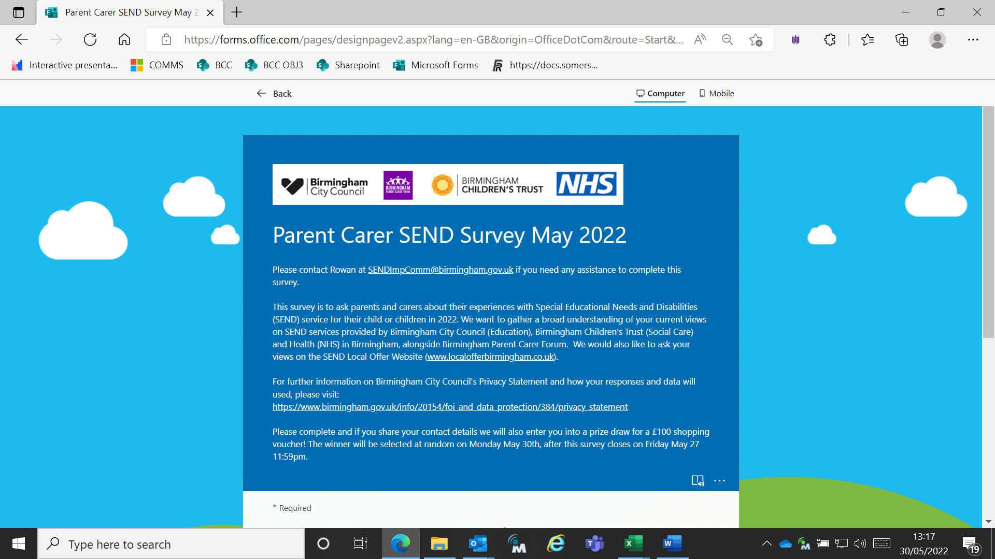

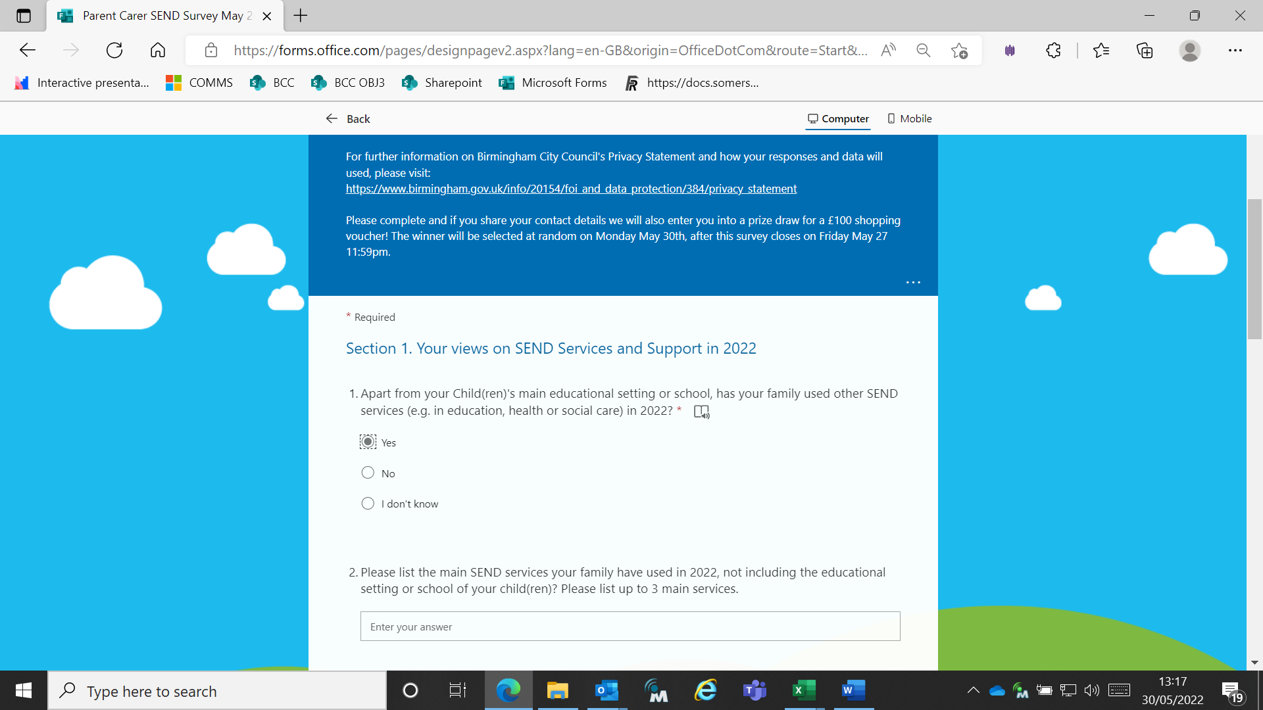

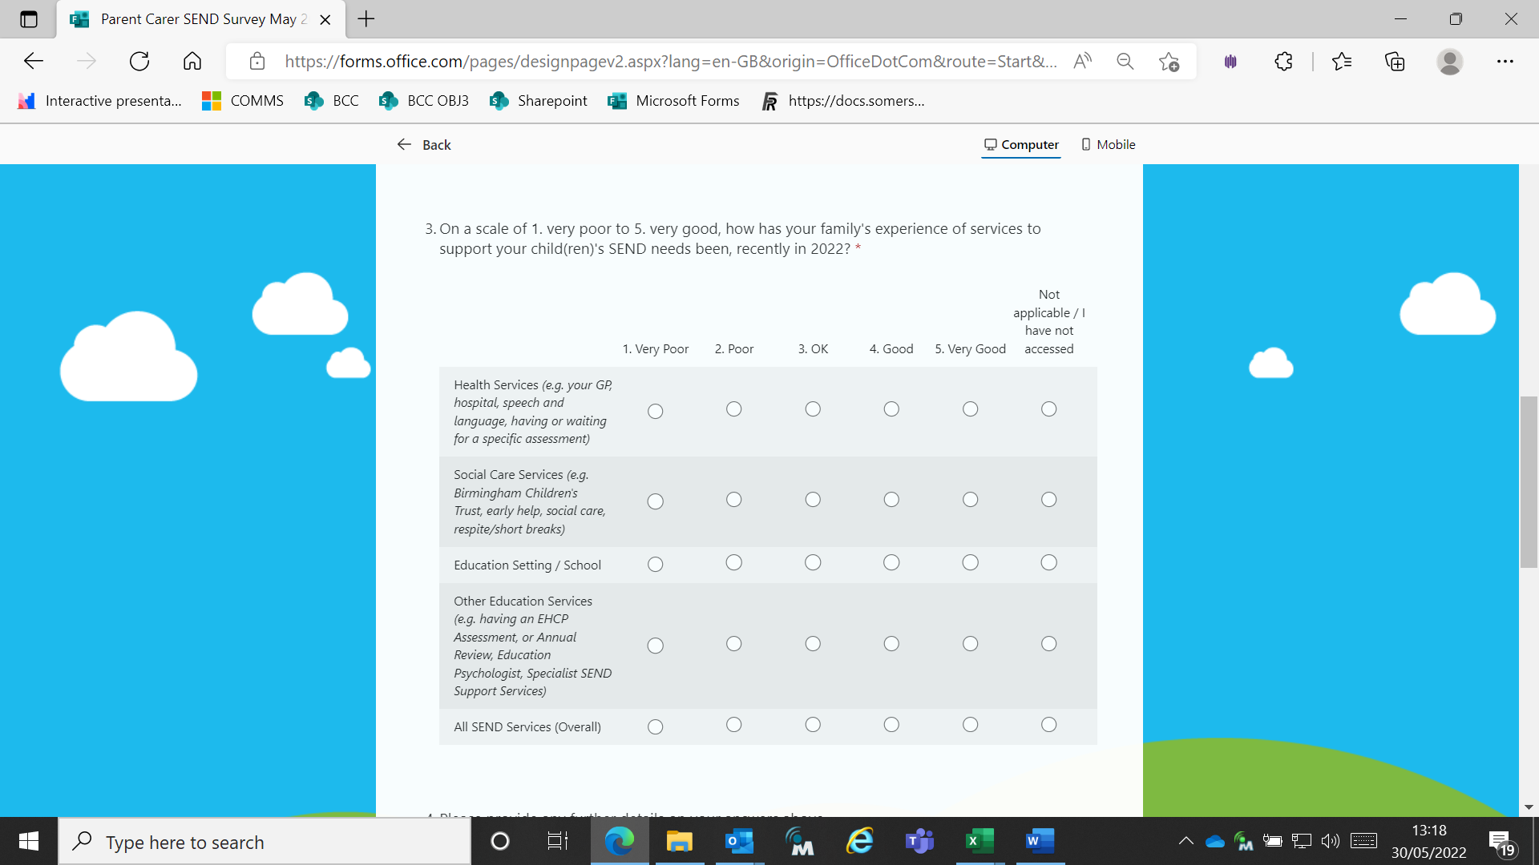

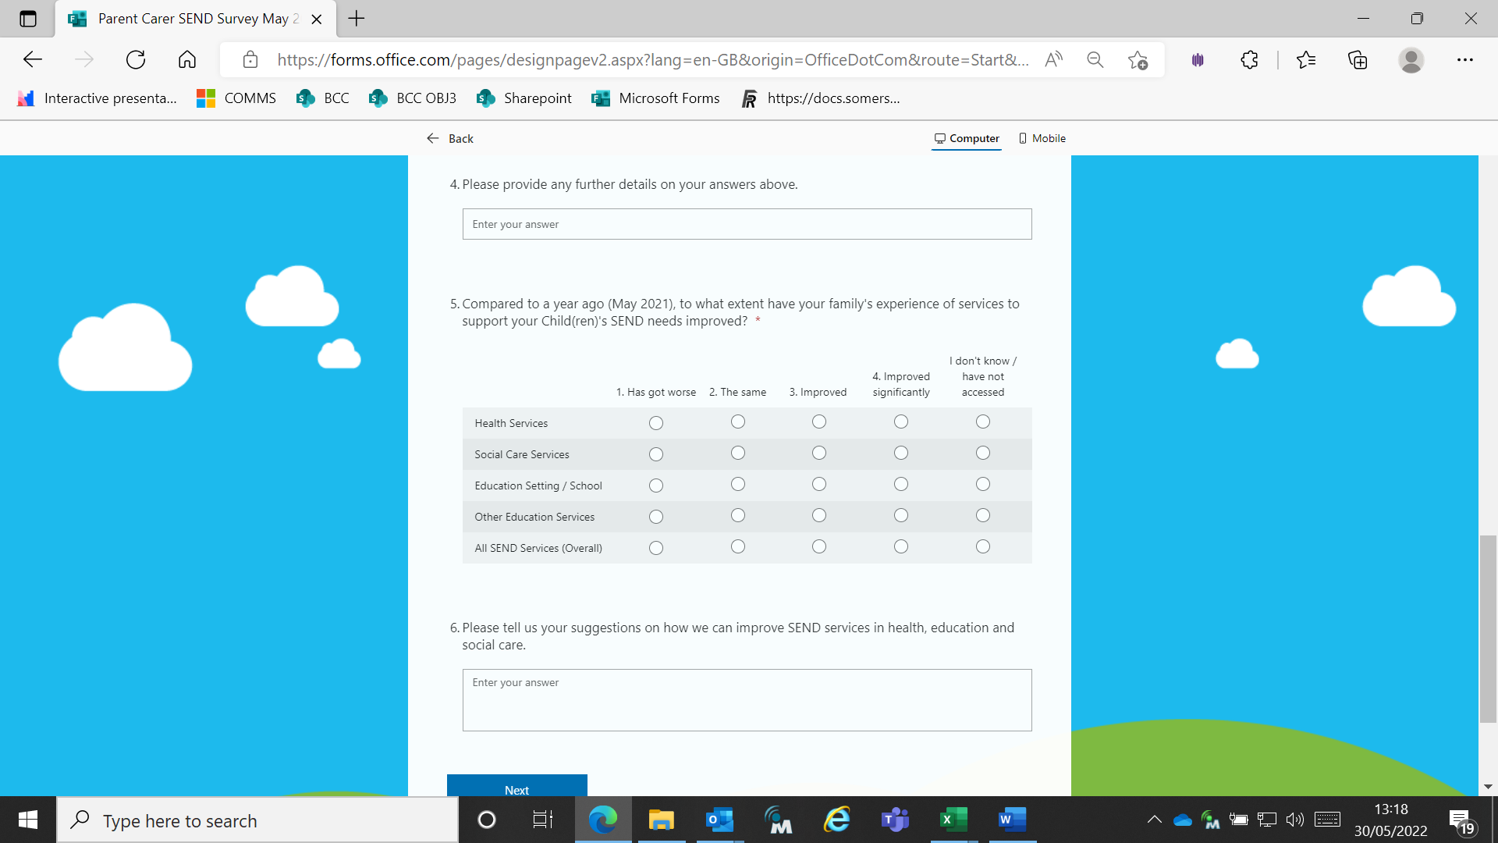

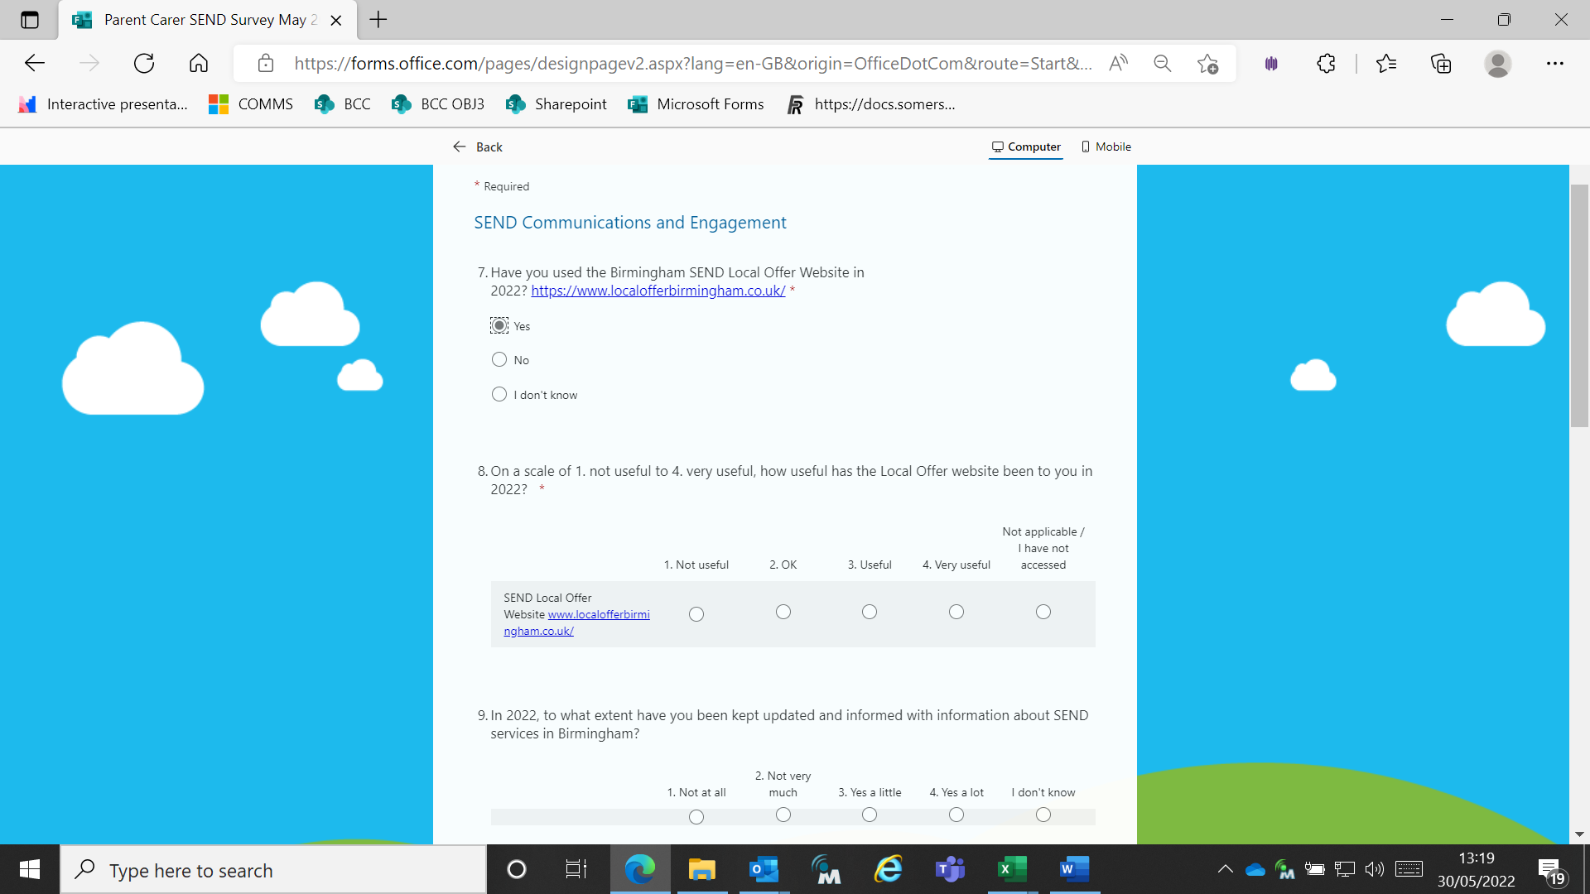

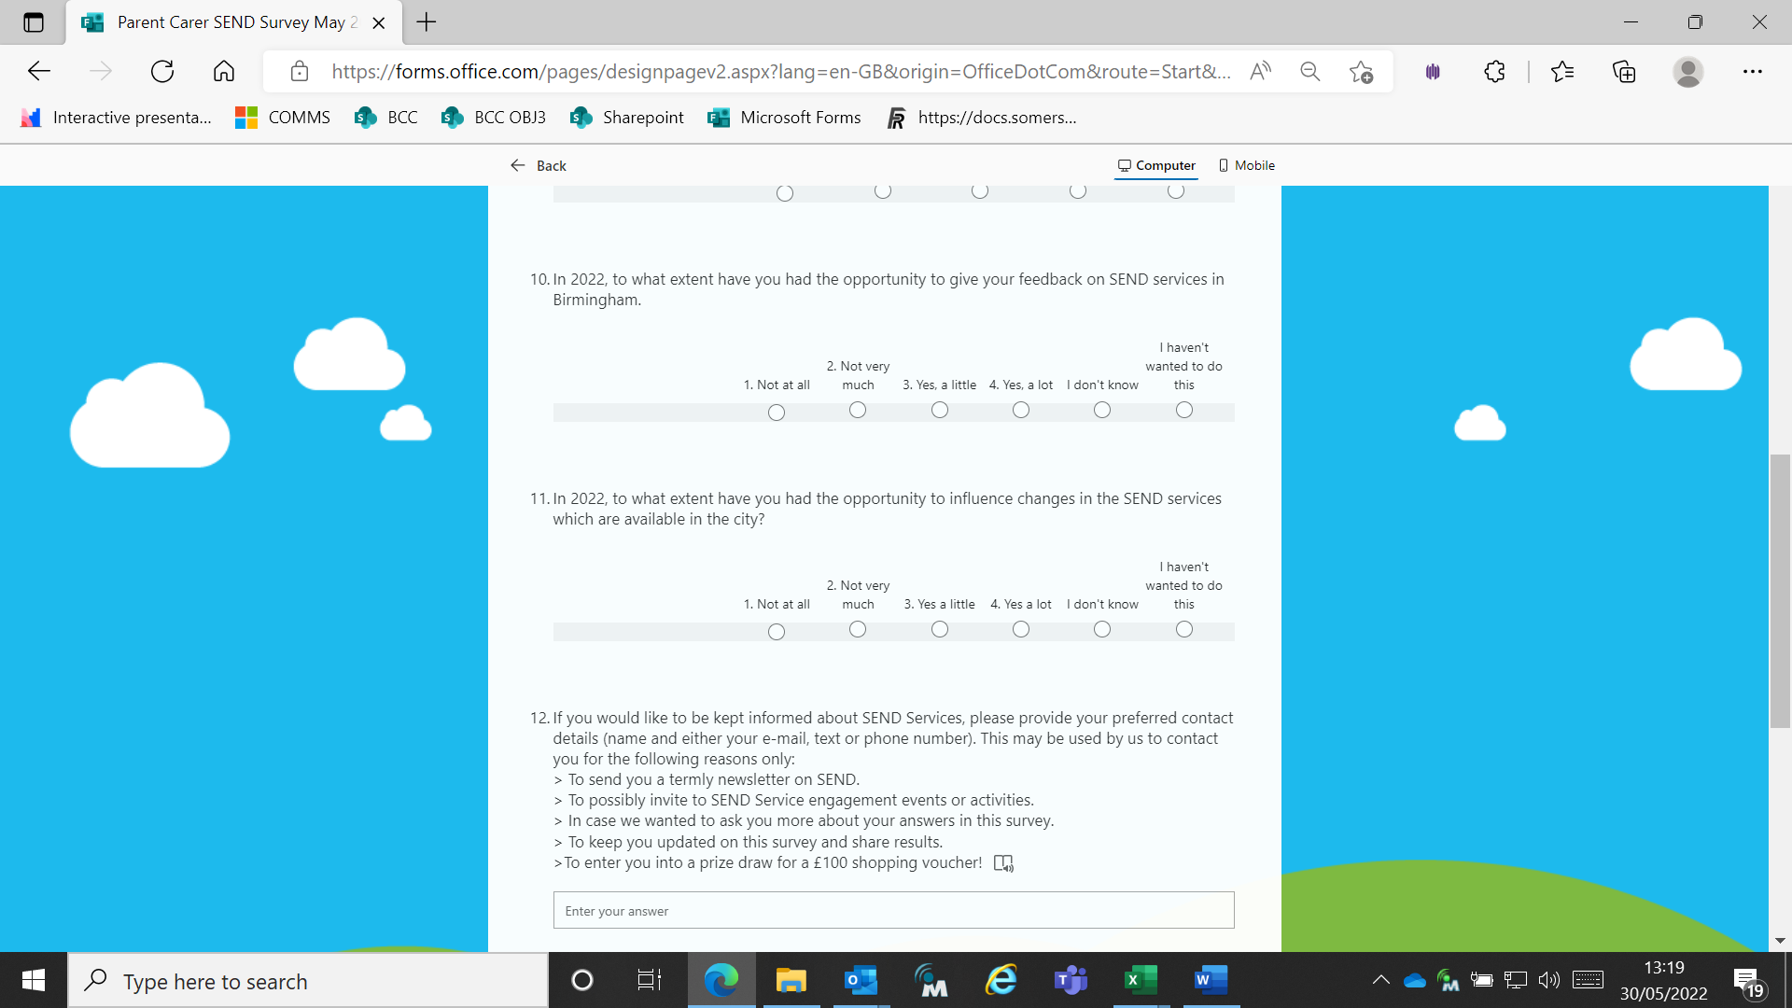

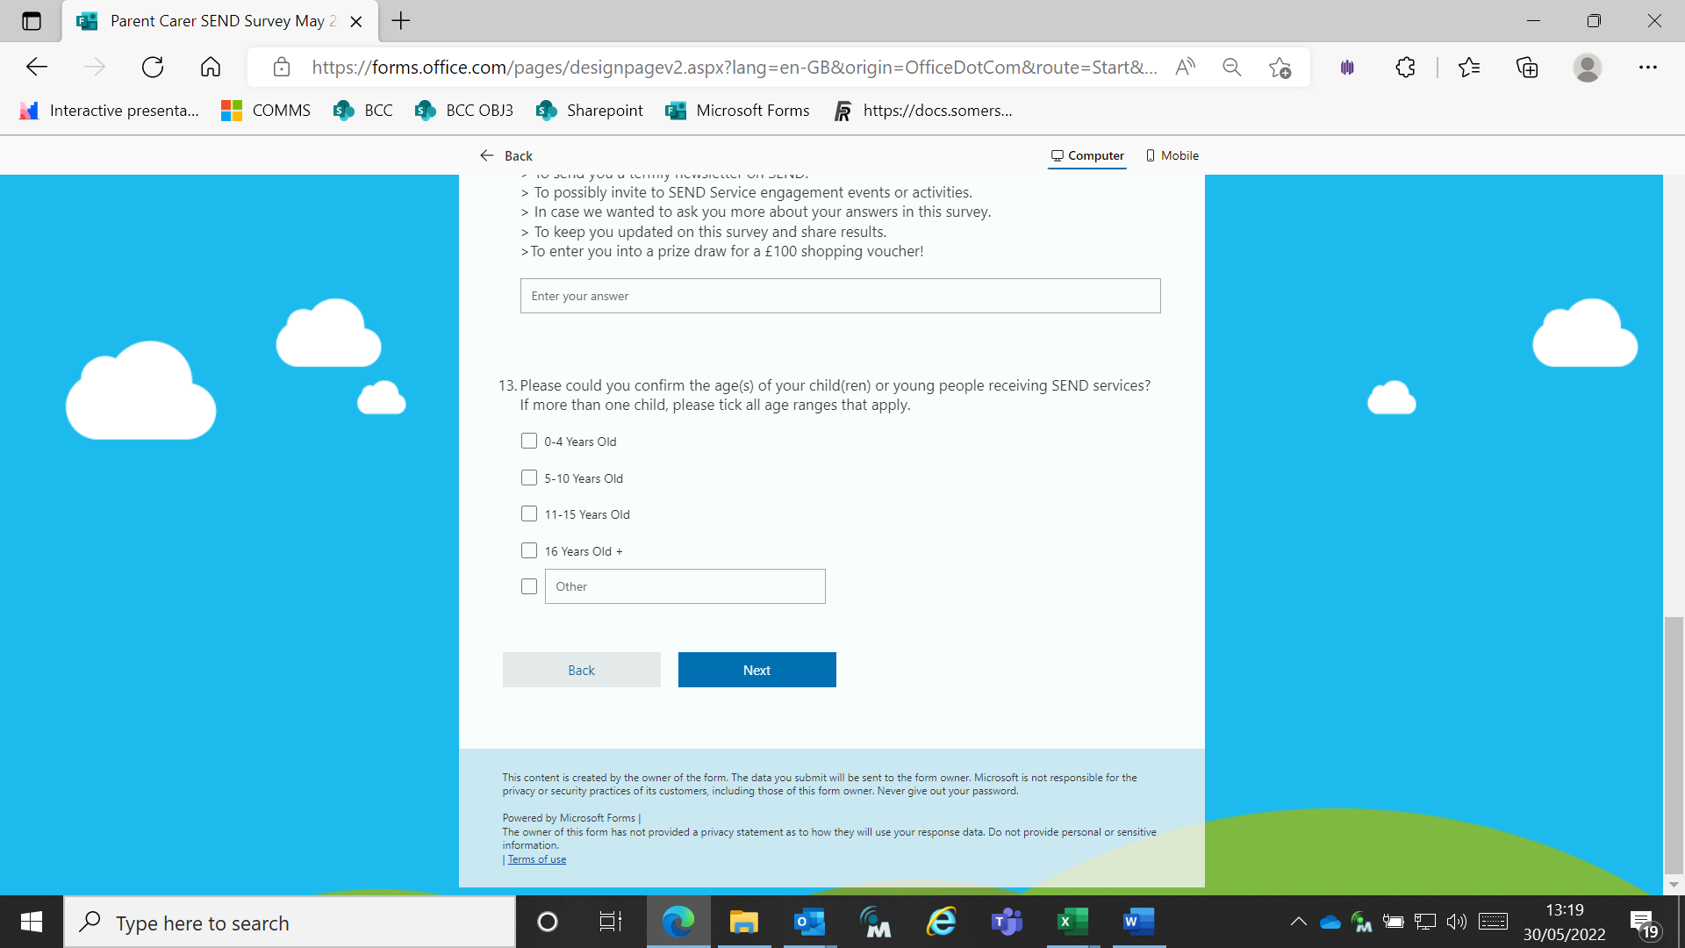

Appendix 2: Key Findings and Recommendations from the Have Your Say Workshops

This survey further validates the findings and recommendation of the Parent Carer Have Your Say Workshops earlier in 2022, during which 93 Parent Carers provided in-depth feedback on their experiences of SEND Services in Birmingham.

Positive responses in the survey validate the responses from parent carer engagement workshops earlier in the year (McCaffrey, Edwards, 2022).

“Thinking about the positive experience of SEND professional support you experienced, what one word best describes how you felt?”

