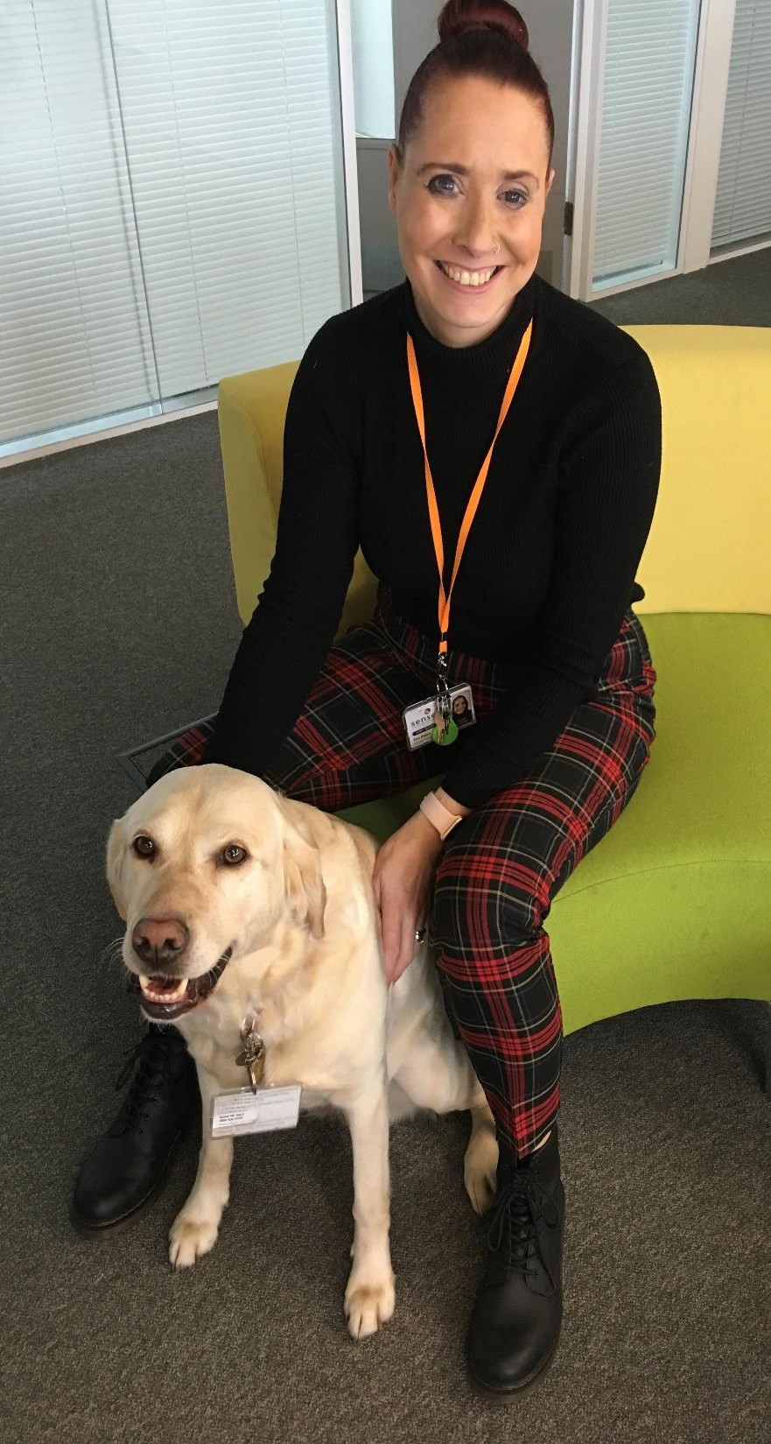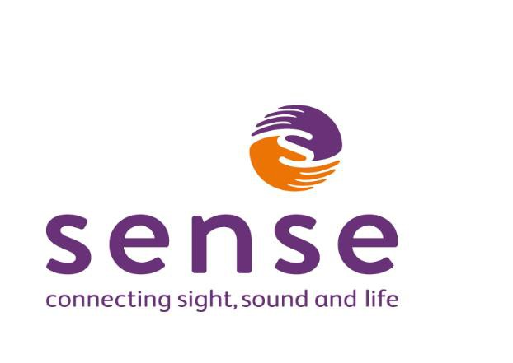

**Benefit Support**

The support I provide for people with dual sensory, sensory impairments and complex disabilities is as follows:

• Information on benefits and concessions for Blind and Partially Sighted People

• Source information on the Certificate of Visual Impairment registration

• Support with PIP applications

• Universal Credit information

• Support with Universal Credit 50 applications

• Support with Attendance Allowance



• General advice regarding the benefits system

**To find out more information or to reserve a spot on any of our sessions please contact Zoe Bates on**

**07557 736294 or email zoe.bates@sense.org.uk**