**Sense’s Employment**

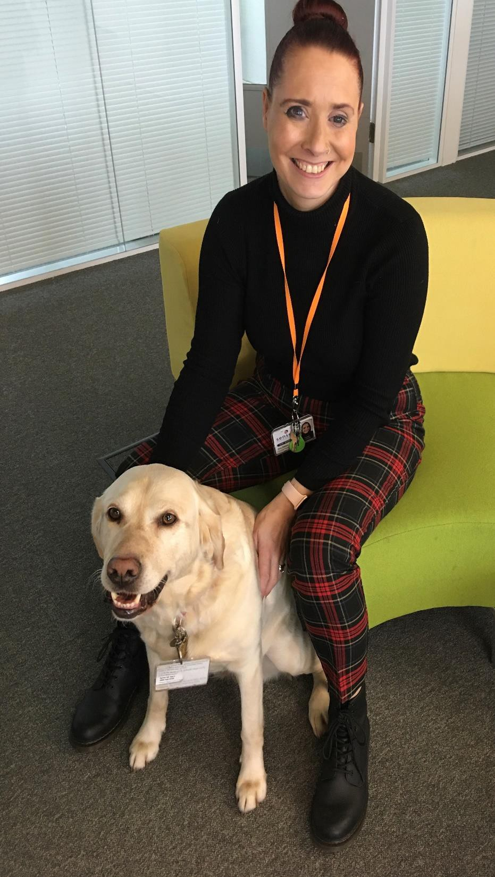

**Programme**

Sense’s Employment Programme supports people who have dual sensory impairments,

complex disabilities or sight impaired, severely sight impaired in the following areas:

• Advice and Guidance on Job Searches

• Revise CV’s, Cover Letter and Applications

• Identify Clients Skills and Aspirations

• Offer tips and guidance on interview techniques

• Support in finding Training Courses

• Information on the Access to Work process

• Accessible equipment advice and Technology Support, excluding purchasing

of equipment, as individual or group sessions

• Review clients job searches

• Run Accredited Pre-Employment Courses

• Hold peer support job club sessions with external guest speakers

• Facilitate assisted job search sessions

• Work in conjunction with course providers to provide accredited courses such as Customer Service, Business Admin etc.

**To find out more information or to reserve a spot on any of our sessions please contact Zoe Bates on**

**07557 736294 or email zoe.bates@sense.org.uk**