Early Identification of Temporary Hearing Loss in Preschool Children
Anna Salo, Educational Audiologist and Teacher of the Deaf, Birmingham Hearing Support Team
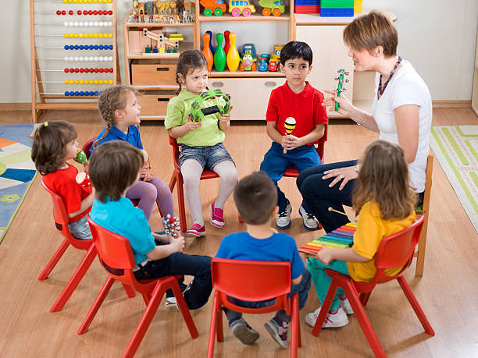
Have you ever thought that a child you are supporting is ignoring you or chooses when to listen? Think again! This child may have an undiagnosed hearing loss!

The article below is linked to an in-depth training session “Supporting Children with a Mild Hearing Loss”, presented by Anna Salo at the Now You’re Talking Birmingham Early Years Conference, 2nd Nov 2022. Image from Pixabay

80% of children under the age of 10, will be affected by a temporary hearing loss at some point in their life. In many cases this loss will be undiagnosed. Parents and professionals supporting young children should be aware of how to spot the signs of a temporary hearing loss in order to minimise its adverse impact on a child’s listening, attention, communication and social skills. This is particularly important considering that the hearing screening check for children in Reception year is no longer carried out in Birmingham.
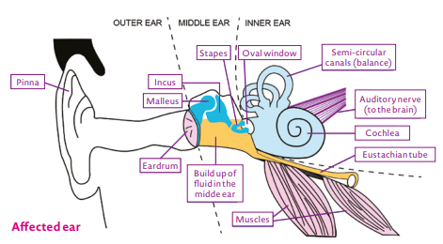

“Glue ear” is caused by the build-up of fluid in the middle ear.
Image from NDCS.org

Temporary hearing loss is very common in young children who are prone to prolonged periods of coughs and colds. This often leads to a build-up of sticky fluid behind the ear drum, which impairs the function of the three ossicle bones in the middle ear. This condition is known as the “glue ear”. It results in a mild or even mild-moderate hearing loss and can affect one or both ears.
Although “glue ear” typically gets resolved without any intervention within three months’ time; (or with the help of an Otovent balloon); for some children it may last much longer. These children may need a grommet surgery or a hearing aid and so the adverse effect may be more severe for this cohort.
The impact of temporary hearing loss on children should not be underestimated. At this young age, children are still developing their auditory skills (listening) and language. This means that children affected by a mild hearing loss may experience the following difficulties:
- not responding in a noisy environment or when the person speaking is at a distance; but responding well when spoken to in a 1:1 situation or in quiet conditions; Image from Pixabay
- mishearing or misunderstanding - may often ask others to repeat what has been said;
- difficulties in concentrating – may appear to be daydreaming;
- when watching the TV, or an iPad, they may turn the volume right up;
- difficulties in understanding speech and following instructions;
- they may use a limited vocabulary range (due to hindered access to incidental learning)
- some may have unclear speech (quieter speech sounds like ‘s’ or ‘sh’ and word endings may be missed or substituted for another);
- they may feel more tired, frustrated or withdrawn.

If you have any concerns about a child’s hearing, talk to the child’s parents/carers. Parents/carers concerned about their child’s hearing should talk to their health visitor or a GP who may refer the child to an audiology clinic. If hearing loss is diagnosed and it lasts more than 3 months, the clinic will advise on the treatment options and will refer to the Hearing Support Team if hearing aids have been issued.

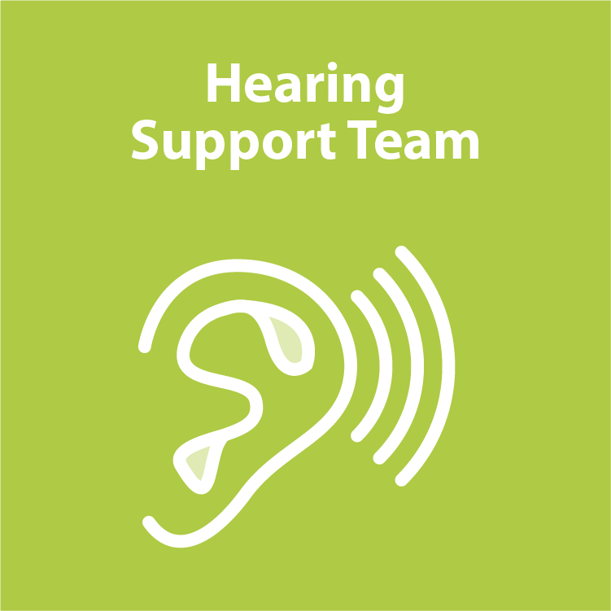
The Hearing Support Team offers timely and effective intervention based on the individual child’s hearing loss and its impact.
For children with a persistent mild hearing loss who have been prescribed hearing aid(s) this support includes:
- advice for parents and professionals
- invitation to our specialist playgroup (children 0-4yrs old)
- on-line training module for parents and professionals
- Management Plan with deaf-friendly strategies for Early Years settings and school staff.
For children with more severe hearing losses, the support is delivered by a visiting Teacher of the Deaf.

For more information on support for children with a hearing loss, visit Birmingham Local Offer website: www.localofferbirmingham.co.uk and then type Hearing Support in the search box.
Other useful information is available from National Deaf Children’s Society www.ndcs.org.uk and BID Services www.bid.org.uk .

Anna Salo, Educational Audiologist (Pg Dip) and Qualified Teacher of the Deaf (Pg Dip)
Sensory Support and Physical Difficulties Support Service – Hearing Support Team (Birmingham)

