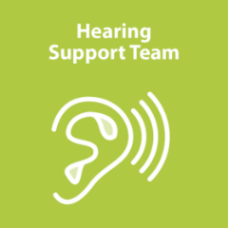
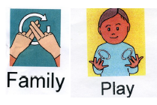
Communicate and Play Join our play-and-stay group sessions for preschool children with a hearing loss!

Is your child aged between 0 – 4 years old? Would you like to meet other parents/carers of children with a hearing loss? Would you like your child to have fun with other children who also wear hearing aids? Come and join our fun play-and-stay sessions run by specialists from the Hearing Support Team.
Who can attend Communicate and Play?
The sessions are open to families of children with any degree of hearing loss. You may meet families with children diagnosed with mild, moderate, severe and profound hearing losses who may wear hearing aids, bone conduction devices or cochlear implants.
What activities are on offer?
Communicate and Play provides a unique opportunity for parents/carers to meet and talk about their children’s hearing journey with other parents/carers and professionals. The sessions are based around a theme and involve free flow play for children, including access to an outdoor space if the weather permits, focus on development of early listening and communication with lots of singing (Hello song, singing nursery rhymes with the associated actions), snack time and learning some everyday signs from the British Sign Language.
Will I have to pay to attend?
The sessions are usually free of charge although we may ask for a little contribution around Christmas and Easter time to help towards the cost of snacks and little gifts for children.
Where does Communicate and Play take place?
Communicate and Play sessions are delivered at two locations:
- Castle Vale Children’s Centre (every other Wednesday at 9:45am - 11:45am)
- Address: Castle Vale Children’s Centre, 372 Yatesbury Avenue, Castle Vale, B35 6DH
- Bacchus Road Children’s Centre (every Thursday at 12.45am - 2.30pm)
- Address: Bacchus Road Children’s Centre, 61 Bacchus Road, Winson Green, B18 4QY
I would like to attend – what do I need to do?
Please note that the centres may be closed on a few occasions across the year, which is why we ask you to contact us before attending. To confirm your place, please let us know which centre you would like to attend and send us your child’s name and date of birth using our secure admin email address: A2EGeneral@birmingham.gov.uk

We hope to see you soon!

