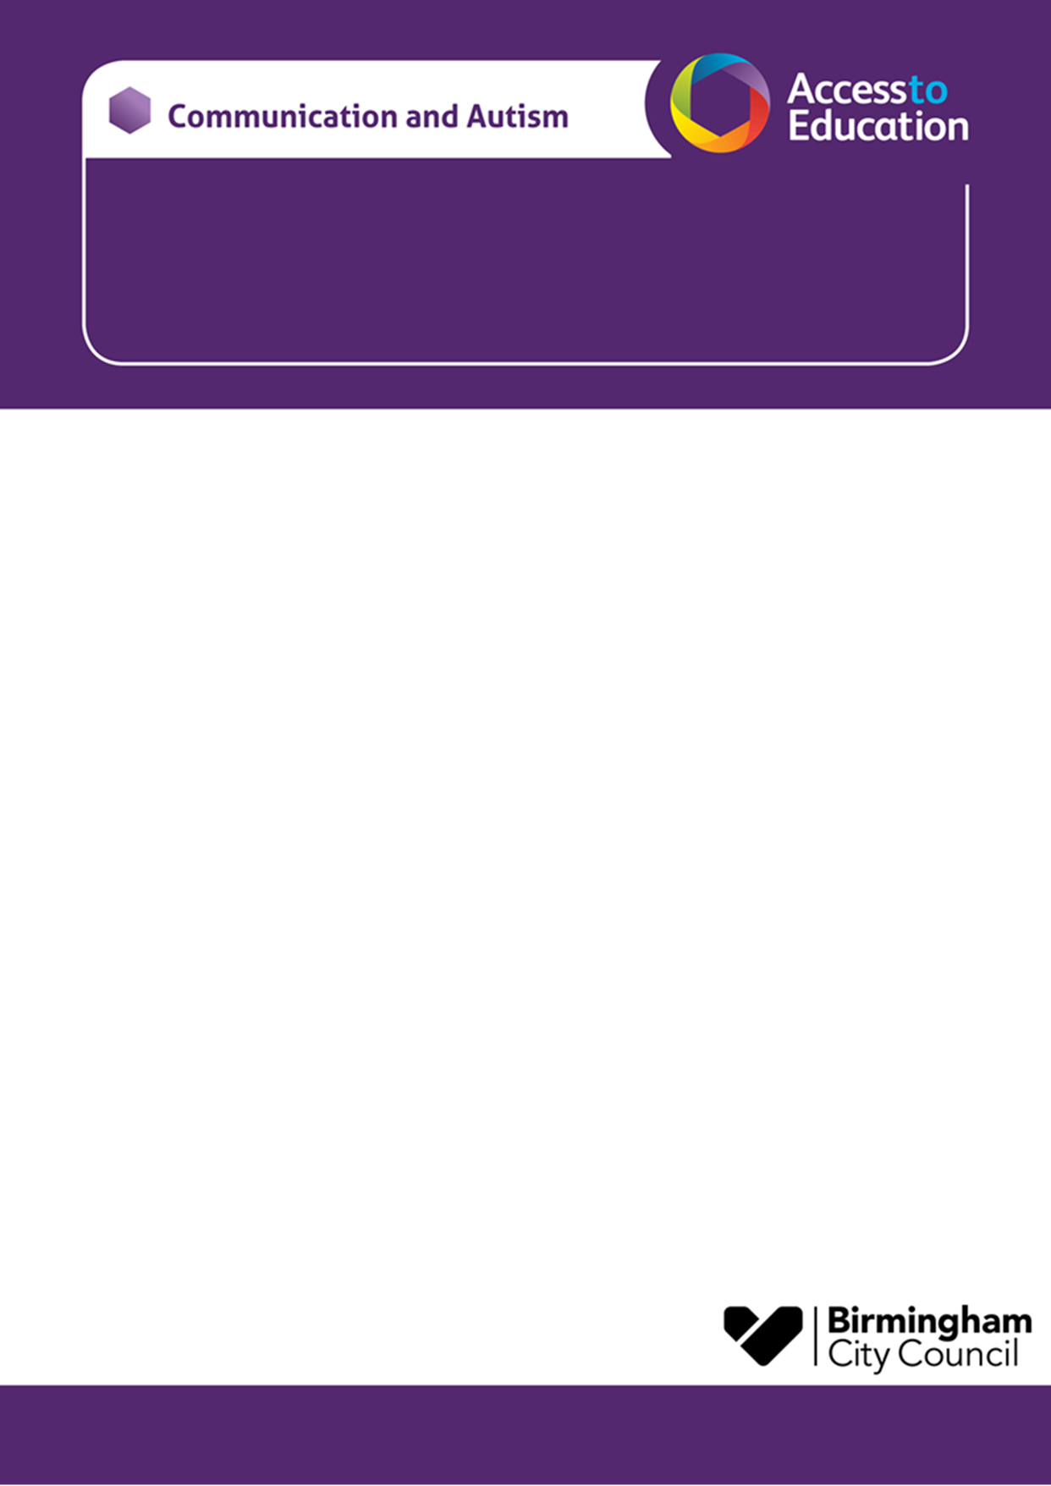

Spring Term 2024 CAT PAC – Secondary Age
Delivered Online

We would like to invite you to a CAT PAC course, our parent awareness course designed to support you following your child receiving a diagnosis of autism.
- The course has been designed for parents who want to increase their understanding of autism.
- The sessions will be delivered virtually via Microsoft TEAMs, a link will be sent to you before each session.
- Each session will last for 2 hours

SPRING TERM 2024

Session1 – What is Autism? | Tuesday 30th January 9.30-11.30am
Session 2 – Social communication | Tuesday 6th February 9.30-11.30am
HALF TERM
Session 3 – Sensory differences | Tuesday 20th February 9.30-11.30am
Session 4 – Teenage issues | Tuesday 27th February 9.30-11.30am
Session 5 – Emotional well-being / Anxiety | Tuesday 5th March 9.30-11.30am
The subject or title of your email needs to state that it is for the :
Spring 2024 Secondary Online CAT PAC.
In your email please include:
- Your name and email address
- Your Child / young person’s name and school
- Your child / young person’s CAT worker (if known)
- Due to limited places, the course will be offered to the first families to contact us.
- There is an expectation that parents endeavour to attend all sessions if possible.
- Please email A2EGeneral@birmingham.gov.uk to reserve a place. You will receive an email response to confirm your place or to tell you that the course is full.
Yours sincerely,
Julie Watchorn Brennan and Lisa Walmsley

