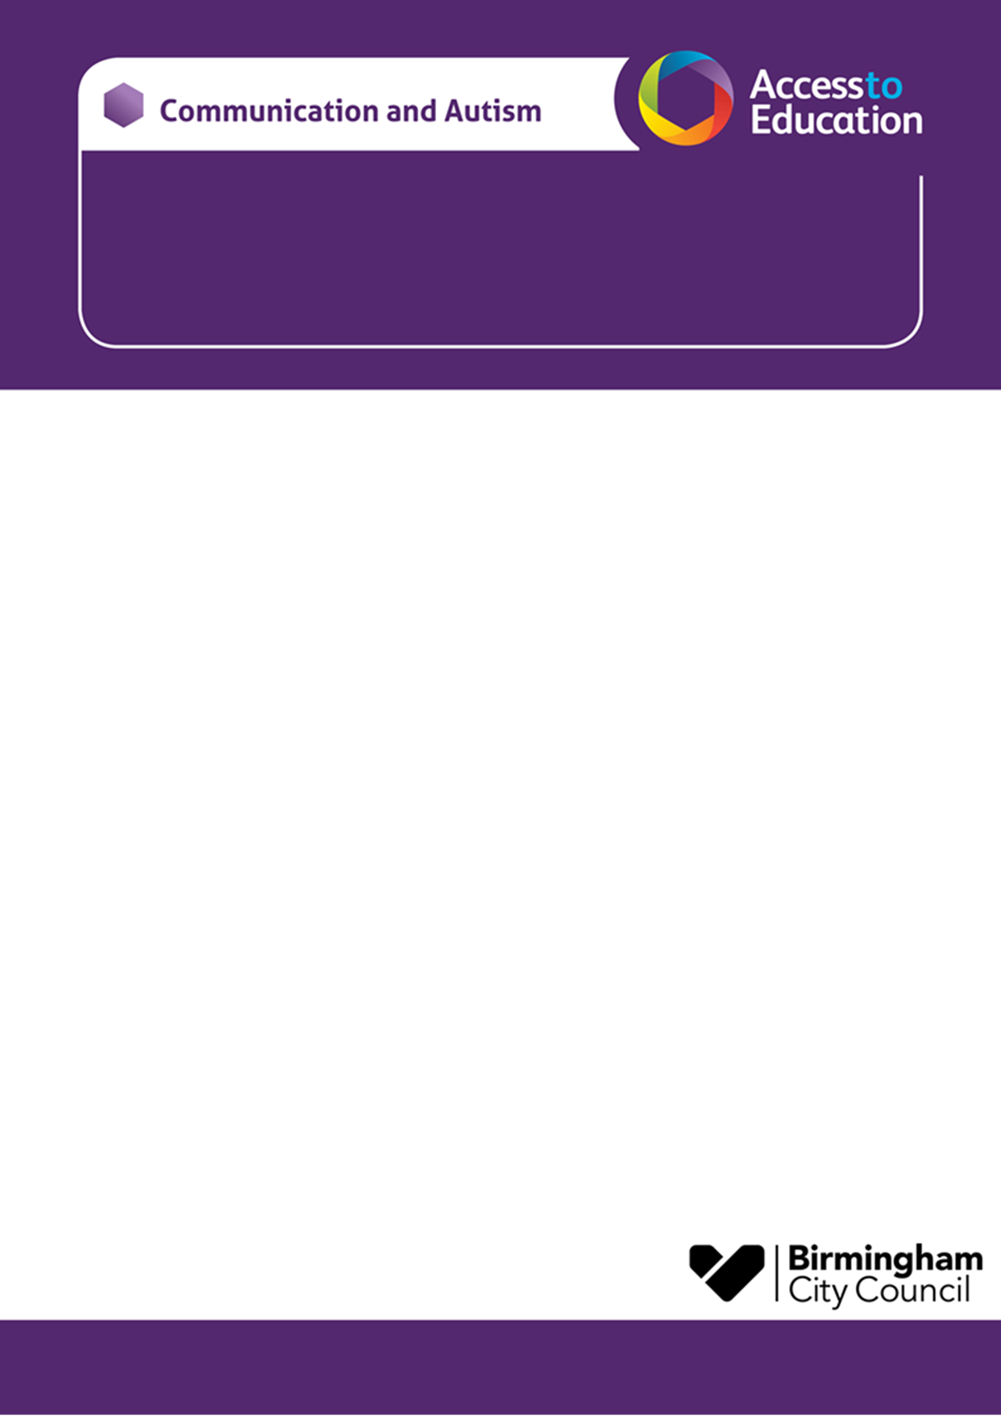

Communication and Autism Team

Parent Session – EAST LOCALITY **Venue tbc**

**Come along and meet Viv and Juliefrom the Communication and Autism Team (CAT).**

**This is an opportunity for you to:**

* **Meet other parent carers with autistic children, or children who are on the neurodevelopmental pathway for assessment**
* **For parent carers of children / young people of all ages**
* **Find out a bit more about autism**
* **Ask questions**
* **Have some time to reflect**

The Spring Workshop Theme is: TBC

The session will be delivered face to face at:

|  |  |
| --- | --- |
| **Venue for Spring term TBC** | **Thursday 14th March 2024**  **9.30-11.30am** |

*Please note: there are no childcare facilities at the venue.*

**If you have any questions, please contact the email below:**

***CATLeadershipTeam@birmingham.gov.uk***

**Just turn up on the day – there is no need to book. We look forward to seeing you there!**

**Viv and Julie**