Annual Review of EHC Plan
Child and Young Persons’ Views
Guidance Notes
This is not the only way to share your views with us, so please do not feel restricted by this form or the language of it. It is more important to us that you are is involved in the process of thinking about your own progress towards your targets and outcomes. | 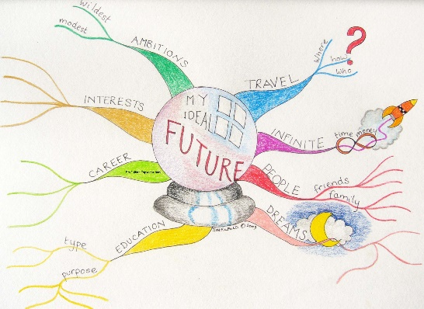
We would like you to tell us how you feel you have been getting on. | 
It would be helpful if you could share some information with us about what you have been doing at the moment and what you would like to be doing in the future. | 
This information will be a really important part of your review that will contribute to an Education, Health and Care Plan (EHCP). | 
The EHCP review is to show the progress you have made and to review the outcomes (long term targets) and provision (the support that helps you with your learning). It should highlight what is working well or if there are any areas that need more support or require changing. | 
Any information you provide is an important part of the review and will be discussed at the EHCP review meeting. | 
We look forward to hearing what you say. Thank you. | 
Section A – Views & Aspirations
Child / Young person Name:
What are your views and interests?
You may like to include/share other things here like photos and drawings which you may prefer to use to express your views:
- What do you like and enjoy about your school / setting?
- What are you good at doing?
- What do you find difficult?
- What do you think would help you in your placement?
- What support might you need with your change (transition) to the next phase of education or to prepare you for leaving education? (if applicable)

What are your aspirations / hopes for the short-term?
- What would you like to learn and achieve by next year?

What are your aspirations / hopes for the long-term?
- What would you like to learn and achieve in the future?
- What would you like to do when you finish education?

Use this space to tell us anything else you would like us to know about how you are getting on at your school / setting? You can use words or pictures!

Form completed by details
Signature of Child / Young Person: | Date:
Printed name of Child/Young Person
Name of person supporting the completion of this form (if applicable): | Date Completed:

