**Assistant Director Inclusion and SEND**

**Education and Skills Directorate**

a way to go. Thank you for your ongoing support and please continue to bear with us over the coming weeks as we progress on our improvement journey.

If you have any questions or comments on this newsletter, or ideas for inclusion, please contact me at [nichola.jones@birmingham.gov.uk](mailto:nichola.jones@birmingham.gov.uk)

Dear families,

Welcome to the second issue of our Home to School Transport newsletter, which aims to keep you informed of the work we are doing to improve the service.

My team and I are committed to providing the best possible home to school transport service for all schools - we know that we still have

With best wishes

**Nichola Jones**

**New support for our travel guides**

We’re delighted that Jennifer Lucas has joined us to support our improvement journey, specifically around our travel guides. We employ over 400 guides and want to ensure our team have the right skills and support to do the job.

Jennifer brings a wealth of experience to the role, having worked for several local authorities to improve their home to school transport service.

“I’m very excited to be working at Birmingham” says Jennifer. “I understand there have been some issues and concerns around the service, however I am committed to working with Nichola and the team to make the improvements needed to create a better experience for everyone involved, especially families.”

Having been a carer for her father who uses an electric wheelchair, Jennifer has first-hand experience not only of the logistics involved in transporting people with special needs, but also how important it is to build a good relationship between families, drivers and guides.

Jennifer will be talking to schools, guides and families over the coming months. If you are interested in finding out more or would like to be involved in helping to improve the home to school transport service, please contact Jennifer at: [Jennifer.lucas@birmingham.gov.uk](mailto:Jennifer.lucas@birmingham.gov.uk)

**HOME TO SCHOOL TRANSPORT NEWSLETTER**

*Information for parents and carers on home to school transport*



***Issue 2 - March 2020***

**Get involved and have your say**

We are very keen for parents, carers and families to be involved and share their views and experiences. Our new Local Offer website will

be up and running at the end of March which will make it easier for people to contact

our teams.

To contact the Home to School Transport service please call 0121 303 4955 or email travelassist@ birmingham.gov.uk. For feedback or general enquiries about your child or young person’s transport service, please call us between 9am and 2.30pm.

**New Parents Transport Guide**

We have produced a new guide to tell you about our home to school transport service. It outlines the responsibilities of parents/ carers, for example providing up-to-date contact details and ensuring that your child is ready on time. It also asks that you let us know if there are any changes, if you have any concerns about your child or if for some reason you don’t require transport. It includes the contact details for parents to get in touch.

**Vehicles undergo regular safety checks**

All vehicles that are used to transport children and young people from their home to school are regularly checked to ensure that they meet the required safety standards.

Since last year, Birmingham City Council has commissioned local company PW Automotive Training to carry out regular, thorough inspections on all vehicles to check their condition and make sure that they are safe and fully roadworthy.

Phil Waterman, who runs PW Automotive Training, explains: “As with any vehicle, there are occasions where faults or defects are found, and these are dealt with on the spot.

“We make sure that no vehicle leaves a depot without being fully checked to make sure it meets the required standards. Parents can be confident that the transport provided for their children is safe.”

**NEAT drivers undertake training programme**

Since taking over the contract for the Home to School Transport and Ring and Ride services across Birmingham last year, NEAT has been busy rolling out a huge training programme for its drivers in order to upgrade their licences.

Around 500 drivers have now taken part in a five-day training programme which involved passing a medical and retaking their driving test.

Vinay Pamar, Managing Director of NEAT comments: “I am pleased that almost all our drivers have now completed their training and apologise for any disruption this may have caused. On behalf of NEAT, I look forward to continuing to work with Birmingham City Council to help them improve their home to school transport service.”

You can find out more about NEAT at: [www.nationalexpress.com/en/neat](http://www.nationalexpress.com/en/neat)

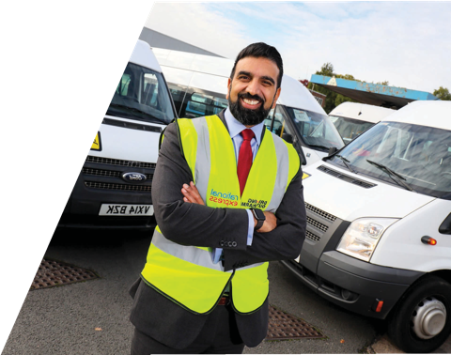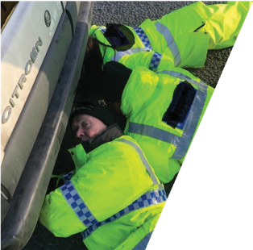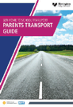

HSB/MAR2020/2