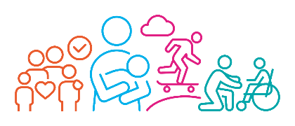

Social Care Advice for Education, Health and Care Needs Assessment
Child / Young Person’s Details
Name |  | Date of Birth
Home Address
School / Setting

Does this replace any previous advice given at stage 1 (YES/NO)

If YES please complete the remaining below

If NO do you require us to use the stage 1 advice provided (YES/NO)

Relevant Background Information

THE OUTCOMES SOUGHT FOR THE CHILD / YOUNG PERSON
Aspiration – Learning and Employment | Outcome | By when
Aspiration – Towards Independence | Outcome | By when
Aspiration – Friendships and Community | Outcome | By when
Aspiration – Keeping Healthy | Outcome | By when

THE CHILD OR YOUNG PERSON’S SOCIAL CARE NEEDS WHICH RELATE TO THEIR SEN

THE CHILD / YOUNG PERSON’S SOCIAL CARE NEEDS WHICH RELATE TO THEIR SEN

SECTION H1: THE OUTCOMES SOUGHT AND SOCIAL CARE PROVISION THAT MUST BE MADE
SOCIAL CARE PROVISION WHICH MUST BE MADE FOR A CHILD OR YOUNG PERSON UNDER 18 RESULTING FROM SECTION 2 OF THE CHRONICALLY SICK AND DISABLED PERSONS ACT 1970 (CSDPA)
Social Care Provision | Frequency | Provided by

SECTION H2: THE OUTCOMES SOUGHT AND SOCIAL CARE REASONABLY REQUIRED
Please remember we only require provision which is beyond the universal offer for relevant needs identified.
SECTION H2
THE SOCIAL CARE PROVISION REASONABLY REQUIRED BY THE LEARNING DIFFICULTIES OR DISABILITIES WHICH RESULT IN THE CHILD OR YOUNG PERSON HAVING SEN
Social Care Provision | Frequency | Provided by

DETAILS OF PROFESSIONAL COMPLETING THE ADVICE
Name |  |  | Title
Service / Agency |  |  | Address
Email Address |  |  | Telephone number
Signature |  | Date advice completed

