Parent/carer views towards the EHC plan annual review (below Y9)
- Outcomes and Aspirations (Section E of EHCP)
Has your child made progress towards the outcomes in their plan?
Is there an area that you feel should be a focus for your child/young person’s outcomes?
What would you like them to achieve by this time next year?
- Please give your views on how well your child/young person has met their outcomes as stated in section E of the plan
- Is there an area you wish them particularly to work on for the next year and beyond? What would you like your child/young person to be able to do in the future? What things could you particularly work on at home?

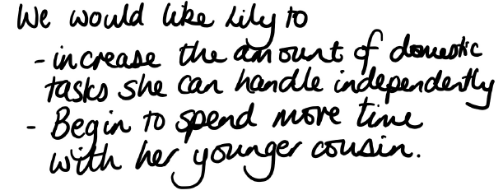

- Is there anything your child/young person can do that they could not do last year (not necessarily official ‘outcomes’)?
- This may relate to academic progress or progress with life or independence skills e.g. getting their own snacks, crossing the road independently, improved toileting, etc

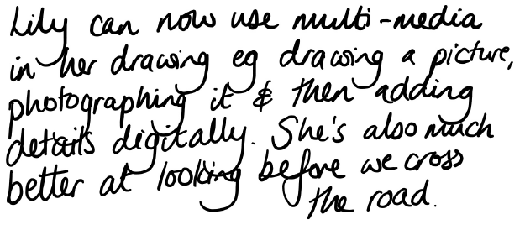

- What has supported your child/young person well this year?
- Please note what has supported your child/young person well this year - this can be at home and/or at school.

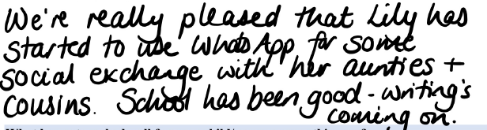

- What has not worked well for your child/young person this year?
- Please not things that you feel have nor supported your child/young person well this year – this can be at home and/or school.

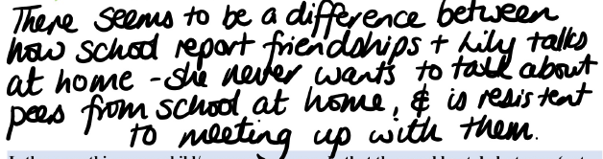

- My Story – Section A of the plan
Has there been any significant changes since the last review?
- Does your child have any new interests?
- Does your child have any new or developing aspiration?
- Do you have any new or developing aspirations for your child?
- Any significant additions to “My story”?

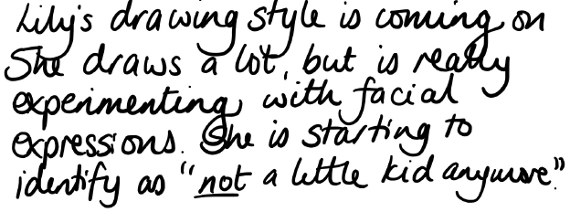

- Strengths and Skills - Section B of the plan
Has there been any significant changes since the last review?
- Consider how strengths and skills have developed, particularly if outcomes have been achieved. Some things that were ‘needs’ before might now be ‘strengths and skills.’
- As your child/young person develops different needs may become more prominent.

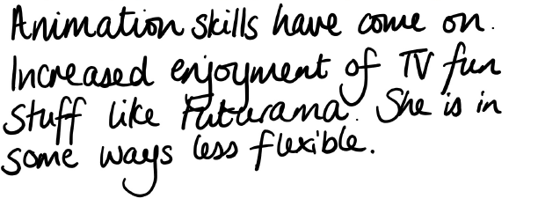

- Provision - Sections C and D of the plan
Has there been any significant changes since the last review?
- Please note any developments or changes to health and social care needs. For example, are there aspects of your child/young person’s health that are better managed than a year ago? Have any new medical challenges arisen? This might also add information to Section A.

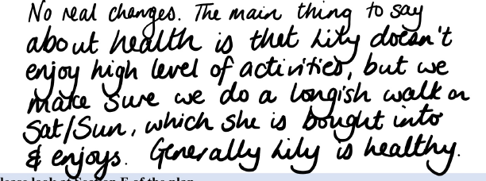

- Is there anything else you would like to share?
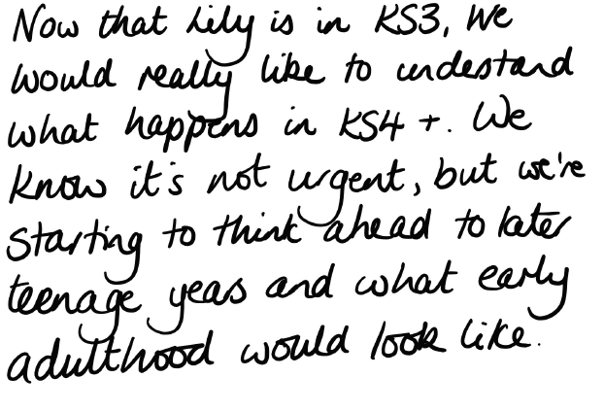

Signed:

Date:

The EHC plan is a document for your child and your views are essential to the process of co-creating it.

